Happy Advertise Video

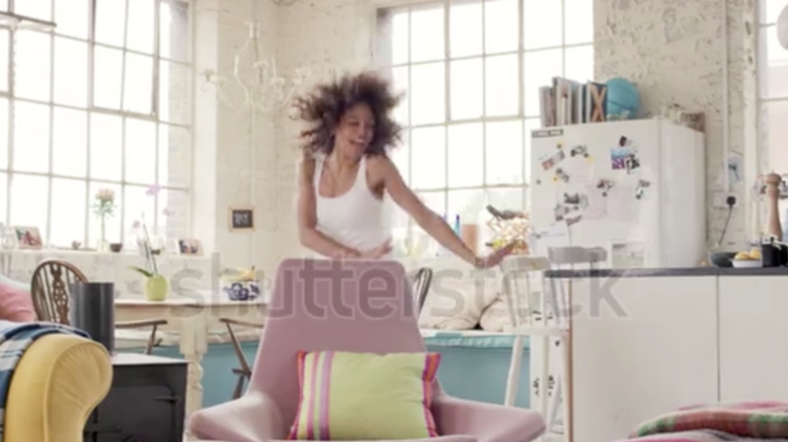

Please fill your instructions and attach this document to your Fiverr order

- Add text for 1st scene (Meet Sofi, 0:00 - 0:2 on the timeline)

- Add text for 2nd scene (She just saved…, 0:5 - 0:8 on the timeline)

- Add text for 3rd scene (You can save too…, 0:8 - 0:10 on the timeline)

- Add your website, slogan or any other text information (0:16 - 0:21 on the timeline)

- Upload your logo (.png file)
Attach Files to Fiverr order

- Personal request
any information that you think we should know

Thank you for ordering :)

Kind regards,
Eighth Studio

