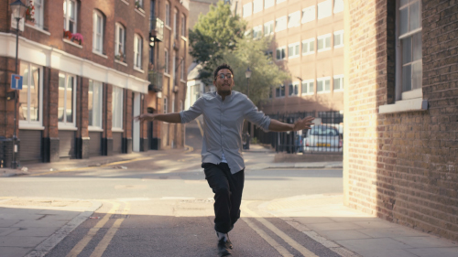
Josh`s Happy Dance

Please fill your instructions and attach this document to your Fiverr order

- Add text for 1st scene (Meet Josh, 0:02 - 0:04 on the timeline)

- Add text for 2nd scene (He just saved…, 0:06 - 0:08 on the timeline)

- Add text for 3rd scene (You can save too…, 0:11 - 0:14 on the timeline)

- Add your website, slogan or any other text information (0:16 - 0:20 on the timeline)

- Upload your logo (.png file)
Attach Files to Fiverr order

- Personal request
any information that you think we should know

Thank you for ordering :)

Kind regards,
Eighth Studio

