ORDER GUIDE

Emma`s Smile
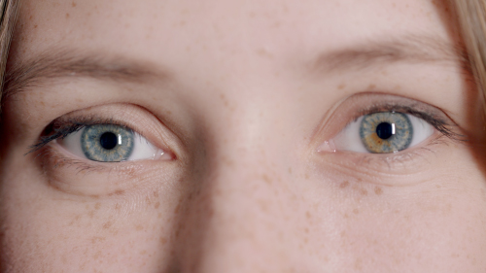

Please fill your instruction and attach this document to your Fiverr order

- Add text for the 1st scene (Find a new home…, 0:07 - 0:12 on the timeline)

- Add your website, slogan or any other text information (0:12 - 0:17 on the timeline)

- Upload your logo (.png file)
Attach Files to Fiverr order

- Personal request
any information that you think we should know

When you fill the form, you should just click on the button «Order Now» in this form. Order our gig and send this form to us.

Thank you for ordering :)

Kind regards,
Eighth Studio

